**CHAPTER 1**

**INTRODUCTION**

* 1. **Aim & Objective**

Our aim is to made a predefined email generator. As we all know that online complaint have a much greater impact and they are basically in tend. As usually when we have some complaint or suggestion we are not able to contact customer care through call which is basically a major problem in India. First of all we have to find a correct customer care number and when we have find a correct customer care number then first of all customer has to choose his problem from a list of options.

After choosing his problem from that list then he is able to contact to a customer care executive. To save our user precious time our project is predefined email generator.

In this we will provide you pre-generated email regarding your problems and you have to just edit your particulars like your name, phone number and then you can send that email.

In our project user will get variety of options regarding his/her complaint and emails according to that complaint and then user can send that email.

In our project user will not only get emails for their complaints but also for their suggestion and feedback.

The emails which we provide will be user friendly as the user as the person with minimum knowledge of computer can easily use our email.

The emails which we provide will have zero grammatical mistakes. Our website will also have email editing flexibility according to user. If user thinks that he/she has to edit something in our email as our email is not upto his requirements according to him in that case the user can edit email and change it according to him and then send it.

If you don’t find any option in our website according to your complaint in that case you can also give us suggestion about that and we will provide you with the email.

As you know you can edit email according to your needs in that case if you thinks that we should keep that change in that email then you can also suggest us about that and we will work on it.

Feedback option will also be provided in our email that If you want to give feedback to any service provider in that case you can give them feedback about any of their services.

We will also provide you with the exact email address of different companies or service providers like Indian railways, Airways, Telecommunication, School/college etc.

As nowadays email complaints will get instant response in comparison to other modes. So to encourage this we are coming with the project of pre-defined email.

**1.2 Software Required**

* HTML(hypertext markup language)
* CSS(Cascaded Stylesheet)
* JAVASCRIPT
* DREAMWEAVER

**1.3 Hardware Required**

* Processor - Intel eleron class Processor with 2.0 GHz
* RAM - 256 MB
* Hard Disk - 40 GB
* Keyboard - 101 keys
* Mouse - Any pointing device

**1.4 Project Focuses On**

* Making Day to Day life easy as useful for one.
* Avoidation of Grammatical mistakes
* Time Saving
* Email editing flexibility according to user
* Free of cost service

**1.5 Design and development**

WEBSITE

SUGGESTION

FEEDBACK

COMPLAINT

RAILWAYS

HOSPITAL

TELECOM

AIRLINES

SCHOOL

COLLEGE

LEAVE FOR APPLICATION

SANITARY

CONDITION

NETWORK

PROBLEM

REFUND

Fig 1.1- FLOW CHART

**CHAPTER 2**

**LITERATURE**

**2.1 Present System**

So we have decided to make this project because we think that there are many problems in present system.

As we know today if you want to register a complaint or want to give any feedback or suggestion then there are many problems in front of us.

First and the main problem is that we have to find a correct customer care number and when we have finally found a customer care number then we have to select our problem from a list of problems and then we can think that we can get solution of our problem.

But this is not the case. When we call a customer care number then sometimes our call is not even answered and by the time our call is answered many of us are frustrated. Then our call is transferred from one department to another and then we get our solution.

In this case also sometimes the customer care executive is not able to understand our problem and he is unable to give us sufficient solution for our problem, then they tell us to wait for their call and the procedure goes on like this.

So to save a person’s time by giving him another option for their complaint, suggestion and feedback we present our project pre-defined email generator.

In our project user can just come and enter his/her complaint and we will provide them with an email regarding that problem. This will help user in getting an instant response/solution for their problem.

We will also provide email for suggestion and feedback. In this case also we will provide email and user can enter his/her suggestion or feedback.

As we know nowadays email complaints get instant response. So to encourage this we provide you with pre-defined email generator. In this precious time of user is saved as he gets an email regarding his/her complaint and user also get instant response regarding their complaint.

In our project there will be no grammatical mistakes. Emails are very well written and fulfill user’s requirements.

If user want to edit something in our email then they can does that and send it.

**2.2 Proposed Model**

Our aim is to make a predefined email generator. As we all know that online complaint have a much greater impact and they are basically in tend. As usually when we have some complaint or suggestion we are not able to contact customer care through call which is basically a major problem in India.

First of all we have to find a correct customer care number and when we have find a correct customer care number then first of all customer has to choose his problem from a list of options.

After choosing his problem from that list then he is able to contact to a customer care executive. To save our user precious time our project is predefined email generator.

In this we will provide you pre-generated email regarding your problems and you have to just edit your particulars like your name, phone number and then you can send that email.

In our project user will get variety of options regarding his/her complaint and emails according to that complaint and then user can send that email.

In our project user will not only get emails for their complaints but also for their suggestion and feedback.

The emails which we provide will be user friendly as the user as the person with minimum knowledge of computer can easily use our email.

The emails which we provide will have zero grammatical mistakes. Our website will also have email editing flexibility according to user. If user thinks that he/she has to edit something in our email as our email is not upto his requirements according to him in that case the user can edit email and change it according to him and then send it.

If you don’t find any option in our website according to your complaint in that case you can also give us suggestion about that and we will provide you with the email.

As you know you can edit email according to your needs in that case if you thinks that we should keep that change in that email then you can also suggest us about that and we will work on it.

Feedback option will also be provided in our email that If you want to give feedback to any service provider in that case you can give them feedback about any of their services.

We will also provide you with the exact email address of different companies or service providers like Indian railways, Airways, Telecommunication, School/college etc.

As nowadays email complaints will get instant response in comparison to other modes. So to encourage this we are coming with the project of pre-defined email.

In our website we will provide you with four different webpages in first webpage we will provide you that which option you want to choose.

In second webpage we will provide you with slides of different options regarding your complaint, suggestion or feedback.

When you choose a particular option of exactly what you need. Then you will get an email for that and you can edit your particulars in that and we will also provide you with email editing option to change your email according to your need and then in last webpage you can send that email.

Our website will provide you service without any charge that is totally free of cost.

**2.3 Research**

We choose our project Pre Defined Email Generator Website as nowdays a common problem persist of not being able to communicate with costumer care as majorly in case of Paytm where refund of money still creates a major problem not only with it , People can need help anytime for any company whether food company etc for which they need to contact costumer care but most of the time it is not possible that at correct time the work is done.

May be its because of any communication gap, Costumer care number not available or invalid or not picking up phone by them or any problem can be there.

To avoid all this nowdays people use online platform like sending mails to company , tweet etc. which is beneficial for the person.

Then too people majorly do some mistake while typing mails to company , school , colleges etc it can be either grammatical or they don’t want to type the mail or they don’t have any idea how to express their problem or what is the format.

So to avoid all this and to encourage the use of online platform we decided to create a website which generally generates the email according to the problem or need of user . Not only the complaint email but also the emails about suggestion and complaint.

The benefits of our website are as there will be no grammatical errors, Format will be provided , user can edit the email according to there flexibility .

For developing the website we used Html , Css , Javascript and Dreamweaver and also took help from book like Html and Css the complete refrence and also online resources of tutorials present on Youtube.com , Wikipedia.com etc.

**2.4 About The Project**

Pre-Defined email generator is simply can say a template generator for the emails needed for the one . As until today there’s no such website which persist so we decided as our topic is pre-defined email generator which clearly tells about the email which is already defined for the user.

The pre-defined email generated website will be very much beneficial as it will be pre defined as the name denotes time saving , and most important there will be no grammatical mistakes as our website will be free of cost .

The website will work as according the user as needed like if the user need to send any complaint to a telecom company then on homepage of our website there will be three options –

* Suggestion
* Complaint
* Feedback

Then the user will click on the complaint option which will lead him to webpage for the one for which he/she has to send the mail regarding out of all the option the user will choose Telecom Companies then the email will be generated according to it and the user will now only need to add there name and additional details of them .

Also the user an edit the mail according to there flexibility, and suggest it to us.

Then the user can send the mail pre defined mail required and complete there task .

There will also be a suggestion complaint or feedback option for our website to like you want to send some suggestion , Complaint or feedback regarding us then you can send .

**2.5 Advantages of the Project**

* Free of Cost Service - First of all our website will be free be use so that’s its easy to use for all and can be used by anyone.
* Ease in communication- By using our website there will be ease in communication to the customer care or any other school college etc as the mail is convenient.
* Avoidation of grammatical mistakes- There will be no grammatical mistakes present in the mail of the websites.
* User Friendly- The website is User friendly so all the options are clearly present and available for the user and the user doesn’t face any difficulty to use it.
* Email Editing Flexibility according to the user- The User can also hve email editing flexibility as if the user need to edit it he/she can and also suggest to us.
* Time Saving- By the Use of our website the user can have their time save and be fast for sending the mails with all the perfection.

**2.6 General Methodology in developing the project**

We have divided our project in different phases and each phase has a deadline and every phase will fulfil a specific task. We have divided our project in different phases so that our project development will become easy.

We divided our project into following phases:

* Research and analysis phase
* Design and analysis phase
* Coding phase
* Testing phase
* Evaluation phase

**2.7 Research and analysis phase**

We will collect data and information required for our project from internet. We choose our project Pre Defined Email Generator Website as nowdays a common problem persist of not being able to communicate with costumer care as majorly in case of Paytm where refund of money still creates a major problem not only with it , People can need help anytime for any company whether food company etc for which they need to contact costumer care but most of the time it is not possible that at correct time the work is done.

May be its because of any communication gap, Costumer care number not available or invalid or not picking up phone by them or any problem can be there.

To avoid all this nowdays people use online platform like sending mails to company , tweet etc. which is beneficial for the person.

Then too people majorly do some mistake while typing mails to company , school , colleges etc it can be either grammatical or they don’t want to type the mail or they don’t have any idea how to express their problem or what is the format.

So to avoid all this and to encourage the use of online platform we decided to create a website which generally generates the email according to the problem or need of user . Not only the complaint email but also the emails about suggestion and complaint.

The benefits of our website are as there will be no grammatical errors, Format will be provided , user can edit the email according to there flexibility .

For developing the website we used Html , Css , JavaScript and Dreamweaver and also took help from book like Html and Css the complete refrence and also online resources of tutorials present on Youtube.com , Wikipedia.com etc.

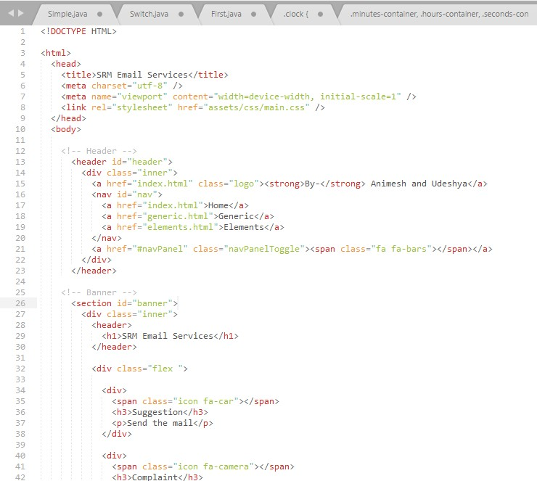**2.8 Coding phase:**

Fig 2.1 Homepage:

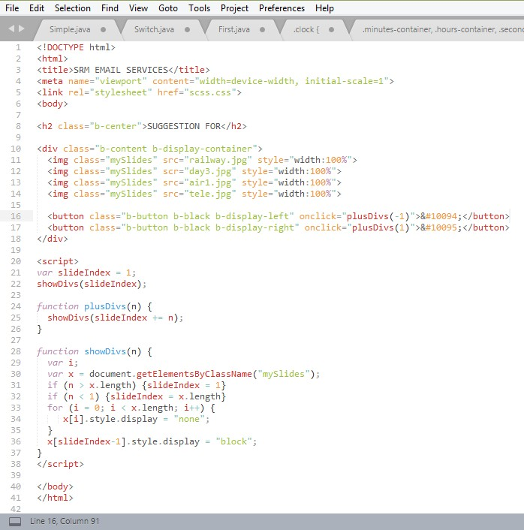fig 2.2 Suggestion Slide (Same is of Feedback and Complaint):

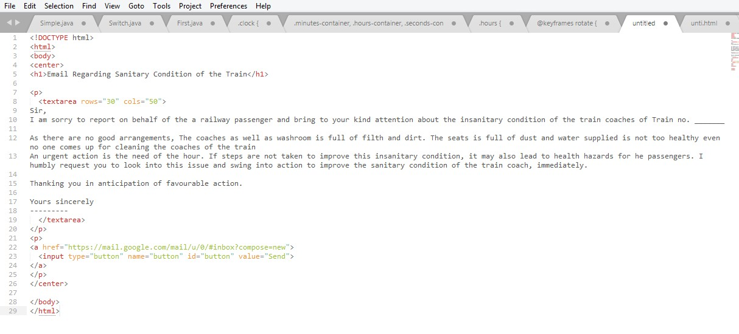fig 2.3 Email Webpage:

**2.9 Testing phase**

This phase is one of the most important phase.

* After the successful compilation of each code we further check the code for any bug or lag.
* We are doing this phase so that we come to know that if there is any bug in our website and also to test that if our website is working smoothly or not.
* Website should be lag less.
* We have tested this website on different browsers and also in incognito mode and in all the browsers our website is working properly.
* We have also tested website is light or not.
* It can handle much of the trafficking. So that it doesn’t lag when very much people surf on our website.
* Also checked that the website is user friendly.
* Website content should be good and free of grammatical mistakes.
* We have tested that all the animations that we have added are working smoothly.
* After success of this phase our website is ready to be used.

**2.10 Evaluation phase**

In this phase we will evaluate the project develop after testing phase. This phase is also one of the most important phase.

These are the following parameters to evaluate our website:

* Evaluate whether the website is secure or not.
* Webpage is light and hence the loading time is less.
* Evaluation of user interface.
* Evaluation of compatibility for different devices.
* Adapted to phone layout.
* Animations added are fast.
* No popups.
* Ad free.
* No premium content.
* Website can even load up within few second even on 2G speeds.

**CHAPTER 3**

**PROPOSED MODEL**

**3.1 Overview**

Our aim is to made a predefined email generator. As we all know that online complaint have a much greater impact and they are basically in tend. As usually when we have some complaint or suggestion we are not able to contact customer care through call which is basically a major problem in India.

First of all we have to find a correct customer care number and when we have find a correct customer care number then first of all customer has to choose his problem from a list of options.

After choosing his problem from that list then he is able to contact to a customer care executive. To save our user precious time our project is predefined email generator.

In this we will provide you pre-generated email regarding your problems and you have to just edit your particulars like your name, phone number and then you can send that email.

In our project user will get variety of options regarding his/her complaint and emails according to that complaint and then user can send that email.

In our project user will not only get emails for their complaints but also for their suggestion and feedback.

The emails which we provide will be user friendly as the user as the person with minimum knowledge of computer can easily use our email.

The emails which we provide will have zero grammatical mistakes. Our website will also have email editing flexibility according to user. If user thinks that he/she has to edit something in our email as our email is not upto his requirements according to him in that case the user can edit email and change it according to him and then send it.

If you don’t find any option in our website according to your complaint in that case you can also give us suggestion about that and we will provide you with the email.

As you know you can edit email according to your needs in that case if you thinks that we should keep that change in that email then you can also suggest us about that and we will work on it.

Feedback option will also be provided in our email that If you want to give feedback to any service provider in that case you can give them feedback about any of their services.

We will also provide you with the exact email address of different companies or service providers like Indian railways, Airways, Telecommunication, School/college etc.

As nowadays email complaints will get instant response in comparison to other modes. So to encourage this we are coming with the project of pre-defined email.

In our website we will provide you with four different webpages in first webpage we will provide you that which option you want to choose.

In second webpage we will provide you with slides of different options regarding your complaint, suggestion or feedback.

When you choose a particular option of exactly what you need. Then you will get an email for that and you can edit your particulars in that and we will also provide you with email editing option to change your email according to your need and then in last webpage you can send that email.

Our website will provide you service without any charge that is totally free of cost.

**3.2 Module**

**3.2.1 HomePage**

The homepage of our predefined email generator include the desing format as a banner which include a background image of a ocean (can be also changed according to need) in which SRM Email Services is Written , also written learn leap and lead in small .

Also name of group members is also added under the main heading banner .

In the above banner we have added a three buttons as mentioned below –

* Suggestion
* Feedback
* Complaint

Also not only for other companies , network companies etc are added but also added for suggestion , complaint and feedback option for our own website in which you can give your view as of suggestion , complaint or feedback regarding to the website.

Also under the lower banner we have added a About the website section in which one can view the purpose of the website and additional data.

We also have added the animation in the main banner section . The Homepage is made light and attractive so as to load faster even on 2g networks.

Also the Homepage has a well defined layout so as to fit in the mobile screen too and desktop.

**3.2.1.1 Suggestion**

In our website we will give you option to give your feedback for any service you used. For that you have to follow following steps.

First of all when you visit our website we will give you three options to be select from. The three options will be suggestion complaint feedback

In our website you can give Suggestion for several things some of the following are below-

* School
* Railways
* Colleges
* Offices
* Hospitals
* Hotels

And also much more. In the suboptions of all this our website will include the following options-

* Sanitary Condition
* Refund
* Network Problems
* Food hygene

Let’s take the case of suggestion. When you click on suggestion on our website then you will be directed to another webpage and there you can select from the list of options that to whom you want to give feedback.

Then you can easily select from the list as there are mostly all the options present that are used in day to day life and you will definitely get the option of your need. That suggestion page slide show will be set to two seconds time.

In every two seconds next slide will be displayed. When you choose option of your choice at that time you will be then directed to a new webpage. In that webpage you will get the suggestion that for which service you want to suggest something.

When you have selected your problem for which you want to give suggestion then you will get a pre-defined email for that. Then you can edit your particulars in that email and send that.

If you think that our email is not sufficient to explain what you want in that case we will also provide you with email editing option so that you can edit email according to your need and then send it.

**3.2.1.2 Feedback**

Our website not only have complaint and suggestion option but also have options for Feedback which is as important as complaint and suggestion.

Like we give feedbackor review about railways etc. In our website you can give feedback for several things some of the following are below-

* School
* Railways
* Colleges
* Offices
* Hospitals
* Hotels

And also much more. In the suboptions of all this our website will include the following options-

* Sanitary Condition
* Refund
* Network Problems
* Food hygene

Like for example one clicks School or colleges then he/she can add feedback about the sanitary condition , Food Hygiene also like if some clicks Railways we will also have mutual options which include Sanitary condition , Food Hygiene as in School / Colleges also have additional options like in railways beside Food hygiene and sanitary condition we have refund feedback etc.

For accessing First when we click on homepage feedback we will redirect to next webpage in which a slider which the options as mentioned below be there the slider automatically slides in every next 2 seconds also manul buttons are added to it .

After clicking one option you will be redirected to nexr webpage where again a slider will occur in where the suboptions will be present.

After clicking on the suboptions the mails regarding the suboptions feedback will occur and the one can edit it according to there flexiblty and add their name etc .

As the mails will be present you can send it by clicking on the button which will redirect you to gmail section where also you can edit it attach something and send it to the one you need which no grammatical mistakes and with correct format .

**3.2.1.3 Complaint**

In our website you also find pre-defined email for complaint for any service you have used. For that you have to follow following steps.

First of all when you visit our website we will give you three options to be select from. The three options will be suggestion, complaint, Feedback .

.In our website you can give complaint for several things some of the following are below-

* School
* Railways
* Colleges
* Offices
* Hospitals
* Hotels

And also much more. In the sub options of all this our website will include the following options-

* Sanitary Condition
* Refund
* Network Problems
* Food hygiene

Let’s take the case of complaint. When you click on suggestion on our website then you will be directed to another webpage and there you can select from the list of options that to whom you want to give complaint.

Then you can easily select from the list as there are mostly all the options present that are used in day to day life and you will definitely get the option of your need. That complaint page slide show will be set to two seconds time.

In every two seconds next slide will be displayed. When you choose option of your choice at that time you will be then directed to a new webpage. In that webpage you will get the complaint that for which service you want to suggest something.

When you have selected your problem for which you want to give suggestion then you will get a pre-defined email for that. Then you can edit your particulars in that email and send that.

If you think that our email is not sufficient to explain what you want in that case we will also provide you with email editing option so that you can edit email according to your need and then send it.

**3.3 Software used**

**3.3.1 Html**

HTML is a computer language devised to allow website creation. These websites can then be viewed by anyone else connected to the Internet. It is relatively easy to learn, with the basics being accessible to most people in one sitting; and quite powerful in what it allows you to create. It is constantly undergoing revision and evolution to meet the demands and requirements of the growing Internet audience under the direction of the » W3C, the organization charged with designing and maintaining the language.

How does it work?

HTML consists of a series of short codes typed into a text-file by the site author — these are the tags. The text is then saved as a html file, and viewed through a browser, like Internet Explorer or Netscape Navigator. This browser reads the file and translates the text into a visible form, hopefully rendering the page as the author had intended. Writing your own HTML entails using tags correctly to create your vision. You can use anything from a rudimentary text-editor to a powerful graphical editor to create HTML pages.

Features of HTML

1) It is a very easy and simple language. It can be easily understood and modified.

2) It is very easy to make effective presentation with HTML because it has a lot of formatting tags.

3) It is a markup language so it provides a flexible way to design web pages along with the text.

4) It facilitates programmers to add link on the web pages (by html anchor tag) , so it enhances the interest of browsing of the user.

5) It is platform-independent because it can be displayed on any platform like Windows, Linux and Macintosh etc.

6) It facilitates the programmer to add Graphics, Videos, and Sound to the web pages which makes it more attractive and interactive.

**3.3.2 Dreamweaver**

Adobe Dreamweaver is a proprietary web development tool from Adobe Systems. It was created by Macromedia in 1997 and developed by them until Macromedia was acquired by Adobe Systems in 2005.

Adobe Dreamweaver is available for macOS and for Windows.

Following Adobe's acquisition of the Macromedia product suite, releases of Dreamweaver subsequent to version 8.0 have been more compliant with W3C standards. Recent versions have improved support for Web technologies such as CSS, JavaScript, and various server-side scripting languages and frameworks including ASP (ASP JavaScript, ASP VBScript, ASP.NET C#, ASP.NET VB), ColdFusion, Scriptlet, and PHP.

Adobe Dreamweaver CC is a web design and development application that combines a visual design surface known as Live View and a code editor with standard features such as syntax highlighting, code completion, and code collapsing as well as more sophisticated features such as real-time syntax checking and code introspection for generating code hints to assist the user in writing code. Combined with an array of site management tools, Dreamweaver lets its users design, code and manage websites, as well as mobile content. Dreamweaver is an Integrated Development Environment (IDE) tool. You can live preview of changes for the frontend. Dreamweaver is positioned as a versatile web design and development tool that enables visualization of web content while coding.

Dreamweaver, like other HTML editors, edits files locally then uploads them to the remote web server using FTP, SFTP, or WebDAV. Dreamweaver CS4 now supports the Subversion (SVN) version control system.

**3.3.3 JavaScript**

JavaScript is a cross-platform, object-oriented scripting language used to make webpages interactive (e.x. having complex animations, clickable buttons, popup menus, etc.). There are also more advanced server side versions of JavaScript such as Node. Js which allow you to add more functionality to a website than simply downloading files (such as real-time collaboration between multiple computers). Inside a host environment (for example, a web browser), JavaScript can be connected to the objects of its environment to provide programmatic control over them.

JavaScript contains a standard library of objects, such as Array, Date, and Math, and a core set of language elements such as operators, control structures, and statements. Core JavaScript can be extended for a variety of purposes by supplementing it with additional objects; for example:

* Client-side JavaScript extends the core language by supplying objects to control a browser and it’s Document Object Model (DOM). For example, client-side extensions allow an application to place elements on an HTML form and respond to user events such as mouse clicks, form input, and page navigation.
* Server-side JavaScript extends the core language by supplying objects relevant to running JavaScript on a server. For example, server-side extensions allow an application to communicate with a database, provide continuity of information from one invocation to another of the application, or perform file manipulations on a server.

This means that in the browser, JavaScript can change the way the webpage (DOM) looks. And, likewise, Node.js JavaScript on the server can respond to custom requests from code written in the browser.

**3.3.4 CSS**

CSS is a language that describes the style of an HTML document.CSS describes how HTML elements should be displayed.

CSS is designed primarily to enable the separation of presentation and content, including aspects such as the layout, colors, and fonts.[3] This separation can improve content accessibility, provide more flexibility and control in the specification of presentation characteristics, enable multiple HTML pages to share formatting by specifying the relevant CSS in a separate .css file, and reduce complexity and repetition in the structural content.

Separation of formatting and content makes it possible to present the same markup page in different styles for different rendering methods, such as on-screen, in print, by voice (via speech-based browser or screen reader), and on Braille-based tactile devices. It can also display the web page differently depending on the screen size or viewing device. Readers can also specify a different style sheet, such as a CSS file stored on their own computer, to override the one the author specified.

Changes to the graphic design of a document (or hundreds of documents) can be applied quickly and easily, by editing a few lines in the CSS file they use, rather than by changing markup in the documents.

The CSS specification describes a priority scheme to determine which style rules apply if more than one rule matches against a particular element. In this so-called cascade, priorities (or weights) are calculated and assigned to rules, so that the results are predictable.

**CHAPTER 4**

**CONCLUSION**

By using our website the user will be able to send the required email for the required purpose.

* Our pages would load faster and we would also be able to maintain the pages we have created with ease.
* In our website there is now no grammatical mistakes
* Now our website is much more light instead of animations added and can be used smoothly
* We have made our website free of cost so it can be accessed by anyone in the whole world.
* Our Website has a simple interface so can be understood very easily by anyone.
* By using our website one’s time can be saved as well as he can accomplish his work.
* By making this project we also got much knowledge about html, css , JavaScript as well as the use of Dreamweaver is also now known to us.

We have done a very hard work in our project as this is our own idea and no website in the market provide this type of facility and we hope that this website comes in trend for the benefit of everyone.

Fig 3.1 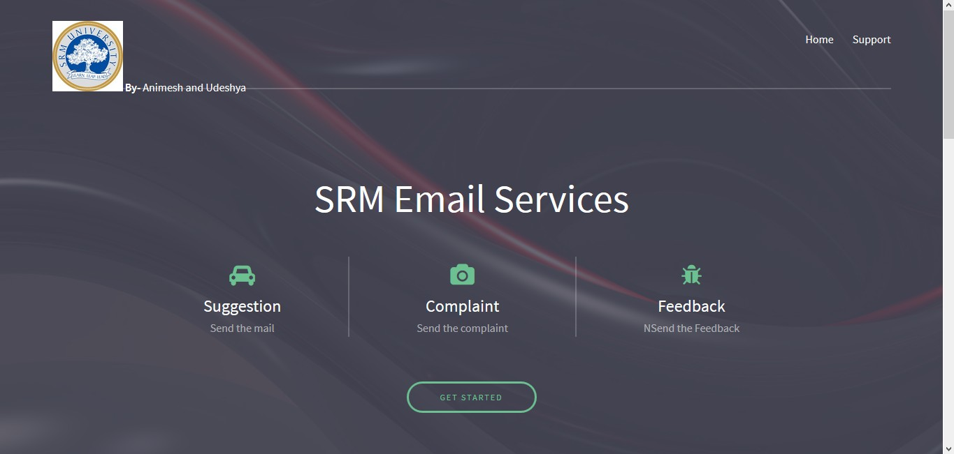Homepage



Fig 3.2 Options Slide Webpage

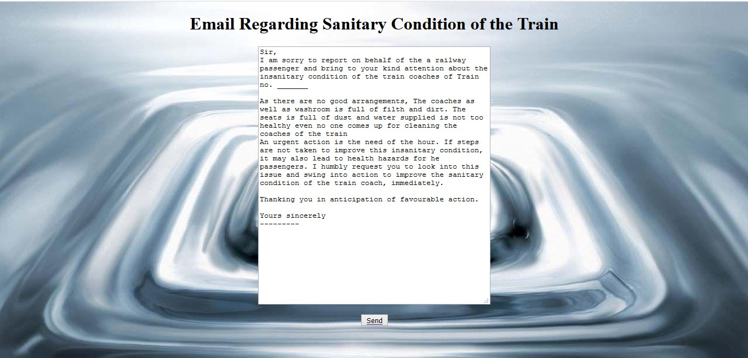

Fig 3.3 Email Webpage-

**REFRENCES**

* https://en.wikipedia.org/wiki/JavaScript
* https://www.tutorialspoint.com
* https://www.w3schools.com/html/
* https://www.youtube.com/watch?v=k3dJKtQmyd0
* https://www.youtube.com/watch?v=ctI1XUjueaE
* https://www.youtube.com/watch?v=nKf8OVyXvrg